Software development skills lab

**PMPML E-CONNECT APP**horizontal line

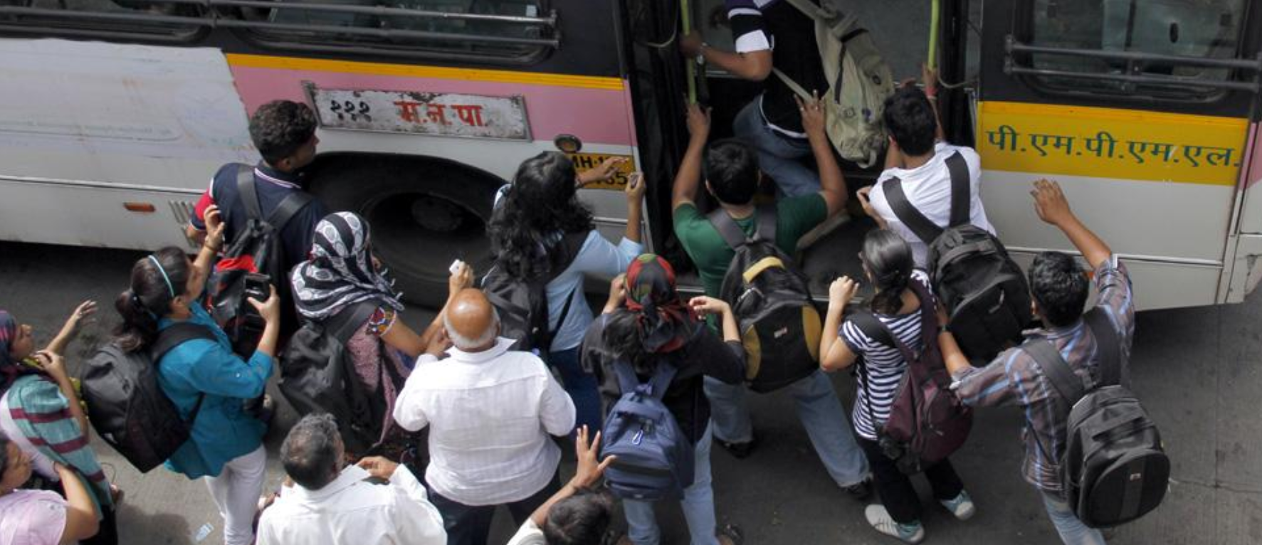

# 

# Authors

Sarita Joshi (31226)

Apoorv Kakade (31227)

Prathamesh Musale (31239)

## 

## Motivation

A recent health survey carried out by MEd students of the Chandrashekhar Agashe Physical Education College on 480 drivers and conductors from PMPML and MSRTC revealed that more than 50 per cent of the sample had above normal BMI index and fat percentage, while 52 per cent was suffering from diabetes, blood pressure or heart-related conditions.

Drivers and conductors do the most hectic job. They claimed that long working hours and poor facilities were the prime reasons for their health problems. Hanumant Tate, general secretary of the MSRTC Workers Union, said, “Though an eight-hour shift has been specified on paper, but they end up working for 10 hours.”

Tate said the checkups were just a formality and not a solution for the problems faced by drivers and conductors. “Having employee-friendly working conditions and better facilities is the only solution,” Tate said. A. N. Anpur, secretary of the PMPL Workers Union, said inadequate manpower was the root cause of the problem, as it prevented drivers and conductors from taking leaves. “Around 3,000 employees are working on daily wages. They don’t get sick or casual leaves. So most of the drivers are suffering from hypertension and blood pressure,” Anpur said.

This app aims at reducing some of the tension for the PMPML staff. Features like online payment for ticket booking, double verification before issuing a ticket, getting real time information about bus timings and routes will help manage the crowd in a better and more efficient way. Conductors do not have to assist each and every person with the tickets as people can do that on their own. Overcrowding will be reduced as people would be aware of the buses nearby.

## Requirement gathering

In a recent survey in [Pune](https://www.commonfloor.com/pune-apartments/),it has been found that Pune Mahanagar Parivahan Mahamandal Limited(PMPML) is unable to tackle the problems faced by the bus commuters. The survey was conducted by Parisar, which is an environmental groupworking towards sustainable transport. The various parameters used in the survey were proper **bus-shelters**, **reliability**, **comfort**, **frequency of the buses**, **Bus station design** and **cleanliness**.

The authority scored a lowly ‘C’ grade in theassessment. The only parameter where the authority had scored well was in **affordability.** But as the Central Bank of India has refused to accept coin deposits from the PMPML citing lack of space. This public sector bank holds the account of the PMPML. “We carry around 12 lakh passengers everyday. The ticket cost is collected in both currency notes and coins. We collect coins worth anywhere between Rs1.5 lakh and Rs 2 lakh every single day,” a PMPML spokesperson said. The bus service has a fleet strength of about 2,000 buses and a daily fare collection of about Rs 1.40 crore.

Even though there was a recent transport utility hike. The study also found that the bus travelling experience was harrowing for passengers due to the various fail outs. The bus services are also not reliable and are prone to cancellations. The figure for cancellation of bus service is a striking 22 percent.

Bus frequency, routes and timetables were acquired from the official website of PMPML.

## Requirement analysis

Officials of Parisar has said that feedbacks of some seven hundred **commuters** were taken into consideration to draw the final conclusion. They also said that these survey will be conducted on a regular basis so as to get a clear picture of the PMPML’s effort towards improvement. The group also gave some solutions to tackle the problems like computerization, proper time-tables at bus stops, proper scheduling of the buses, amongst others.

This project addresses some of the problems stated by the commuters. They are as follows-

1. **Reliability**

Changes in bus routes and timetables will be notified to the commuters through the app.

During festivals, road construction periods, etc., temporary bus routes will be announced.

If a bus breaks down, real time notifications can be sent to commuters by the drivers to

close that trip.

1. **Payment options**

Since October 4 2018, the Central Bank of India has refused to accept coin deposits from

the PMPML citing lack of space. This public sector bank holds the account of the PMPML. They cannot request citizens using PMPML services to not give coins.

A large portions of the commuters own a smartphone and use online payment apps. These online payment options will be given to the users. A personal mobile wallet is available in the app. This will reduce the issues regarding coin collection and also support digital India campaign.

1. **Going Paperless**

We are generating tickets online on the server. Thus there will be no requirement for printing the huge number of tickets everyday. One ticket can be used only once. It will contain the usual details of the trip and can be verified by the TC.

1. **Assisting complaints**

Many times the user complaints are not assisted with. The app will provide a functionality to take user complaints and send them directly to the officials.

## 

## Problem statement

This app aims at reducing some of the tension for the PMPML staff. The app includes features like online payment for ticket booking, double verification before issuing a ticket, getting real time information about bus timings and routes to help manage the crowd in a better and more efficient way. Conductors do not have to assist each and every person with the tickets as people can do that on their own. Online tickets will be generated and can be verified by the Ticket Checker. People can check the information about the buses, routes. They can file a complaint if they face certain issues.

## Architecture Diagram

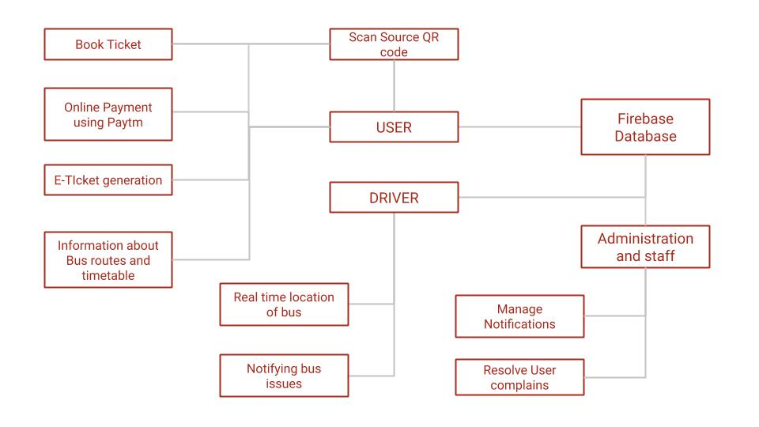

## Technology Stack

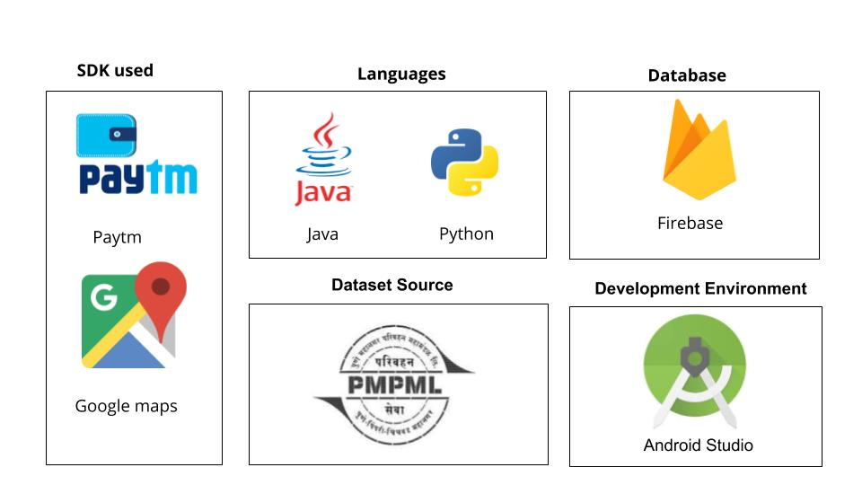

**Algorithm/API Used:**

**FireStore Api:**

Get a Document:

DocumentReference docRef = db.collection("cities").document("SF");

docRef.get().addOnCompleteListener(new OnCompleteListener<DocumentSnapshot>()

Get Multiple Documents from firebase:

db.collection("cities")

.whereEqualTo("capital", true)

.get()

.addOnCompleteListener(new OnCompleteListener<QuerySnapshot>()

Get All documents in a collection:

db.collection("cities")

.get()

.addOnCompleteListener(new OnCompleteListener<QuerySnapshot>()

Add a Document:

db.collection("cities").document("new-city-id").set(data);

## FLOW:

User Opens the App.

User then scans the barcode of the source stop using the embedded barcode scanner in the app.

Source has two directions:to and fro.Depending on which side of the road the barcode is the direction is decided.Direction helps in deciding which destinations he/she might go to.

He/She selects the Bus number from the available Buses(Having the Source).

He/She selects Destination Stop,where he wants to go.

He/She then selects the number of adults and number of children.

Ticket Price is calculated and displayed to him.

He/She Selects whether he /she wants to proceed or not.

After he/she proceeds,if he/she has enough tokens ticket is issued to him/her.

Tickets are purchased using user tokens which can be purchased by using paytm.

Tickets are saved to database and can be viewed and deleted anytime.

## Screenshots:

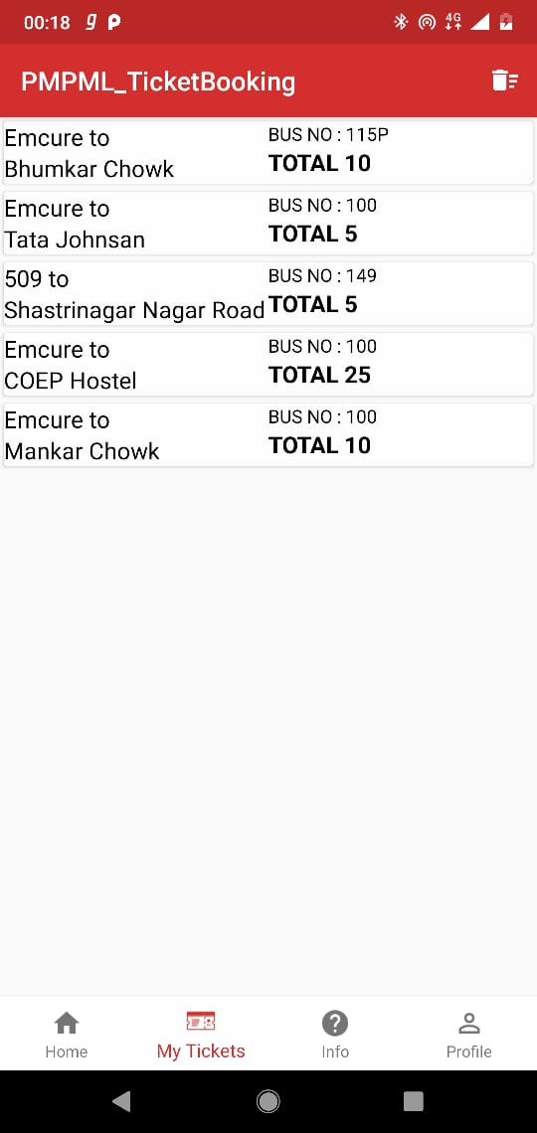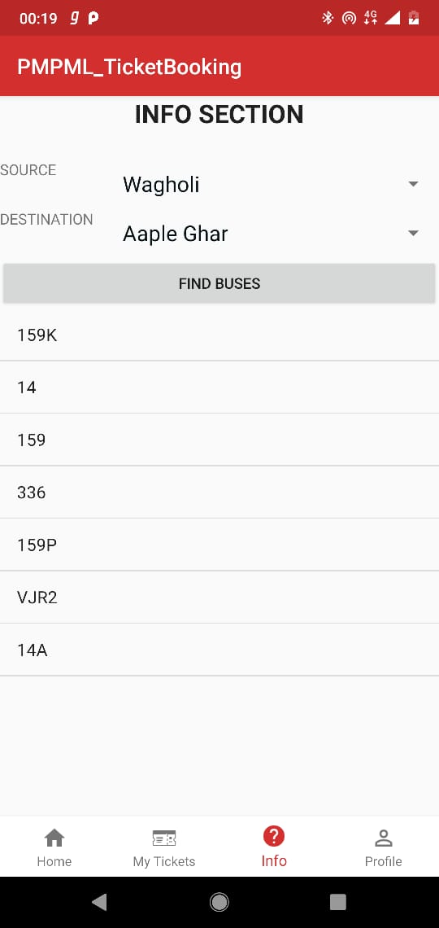

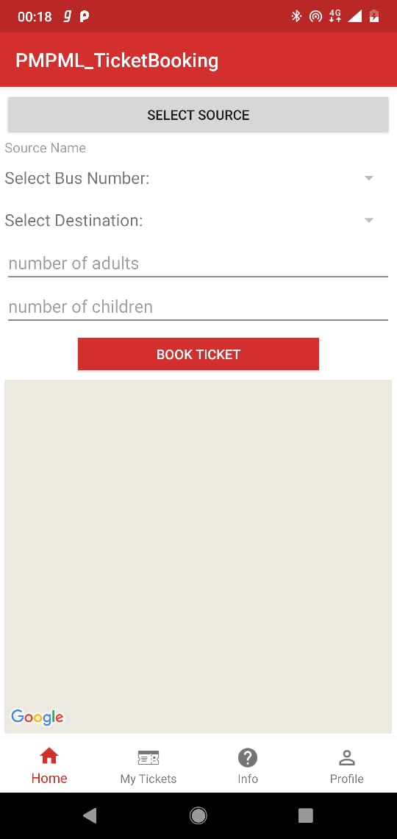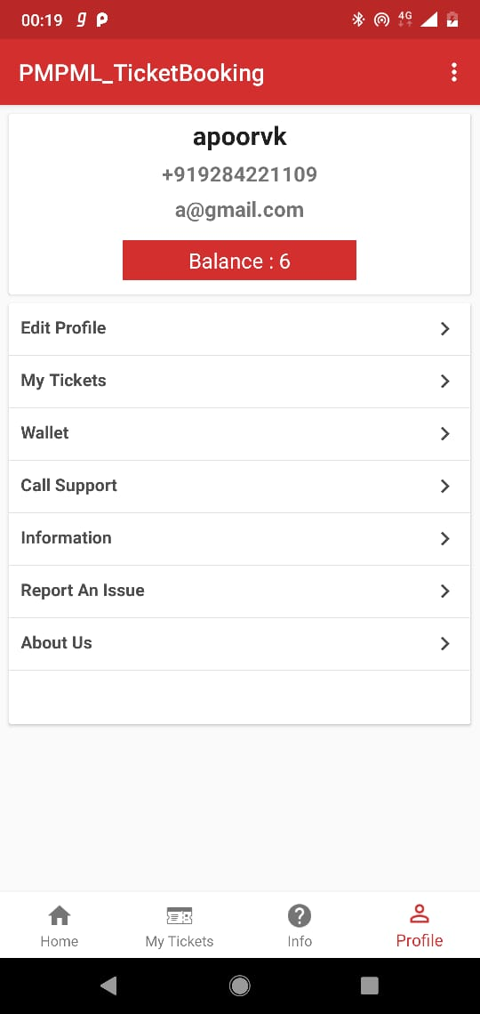

## 

## UML Use Case Diagram:

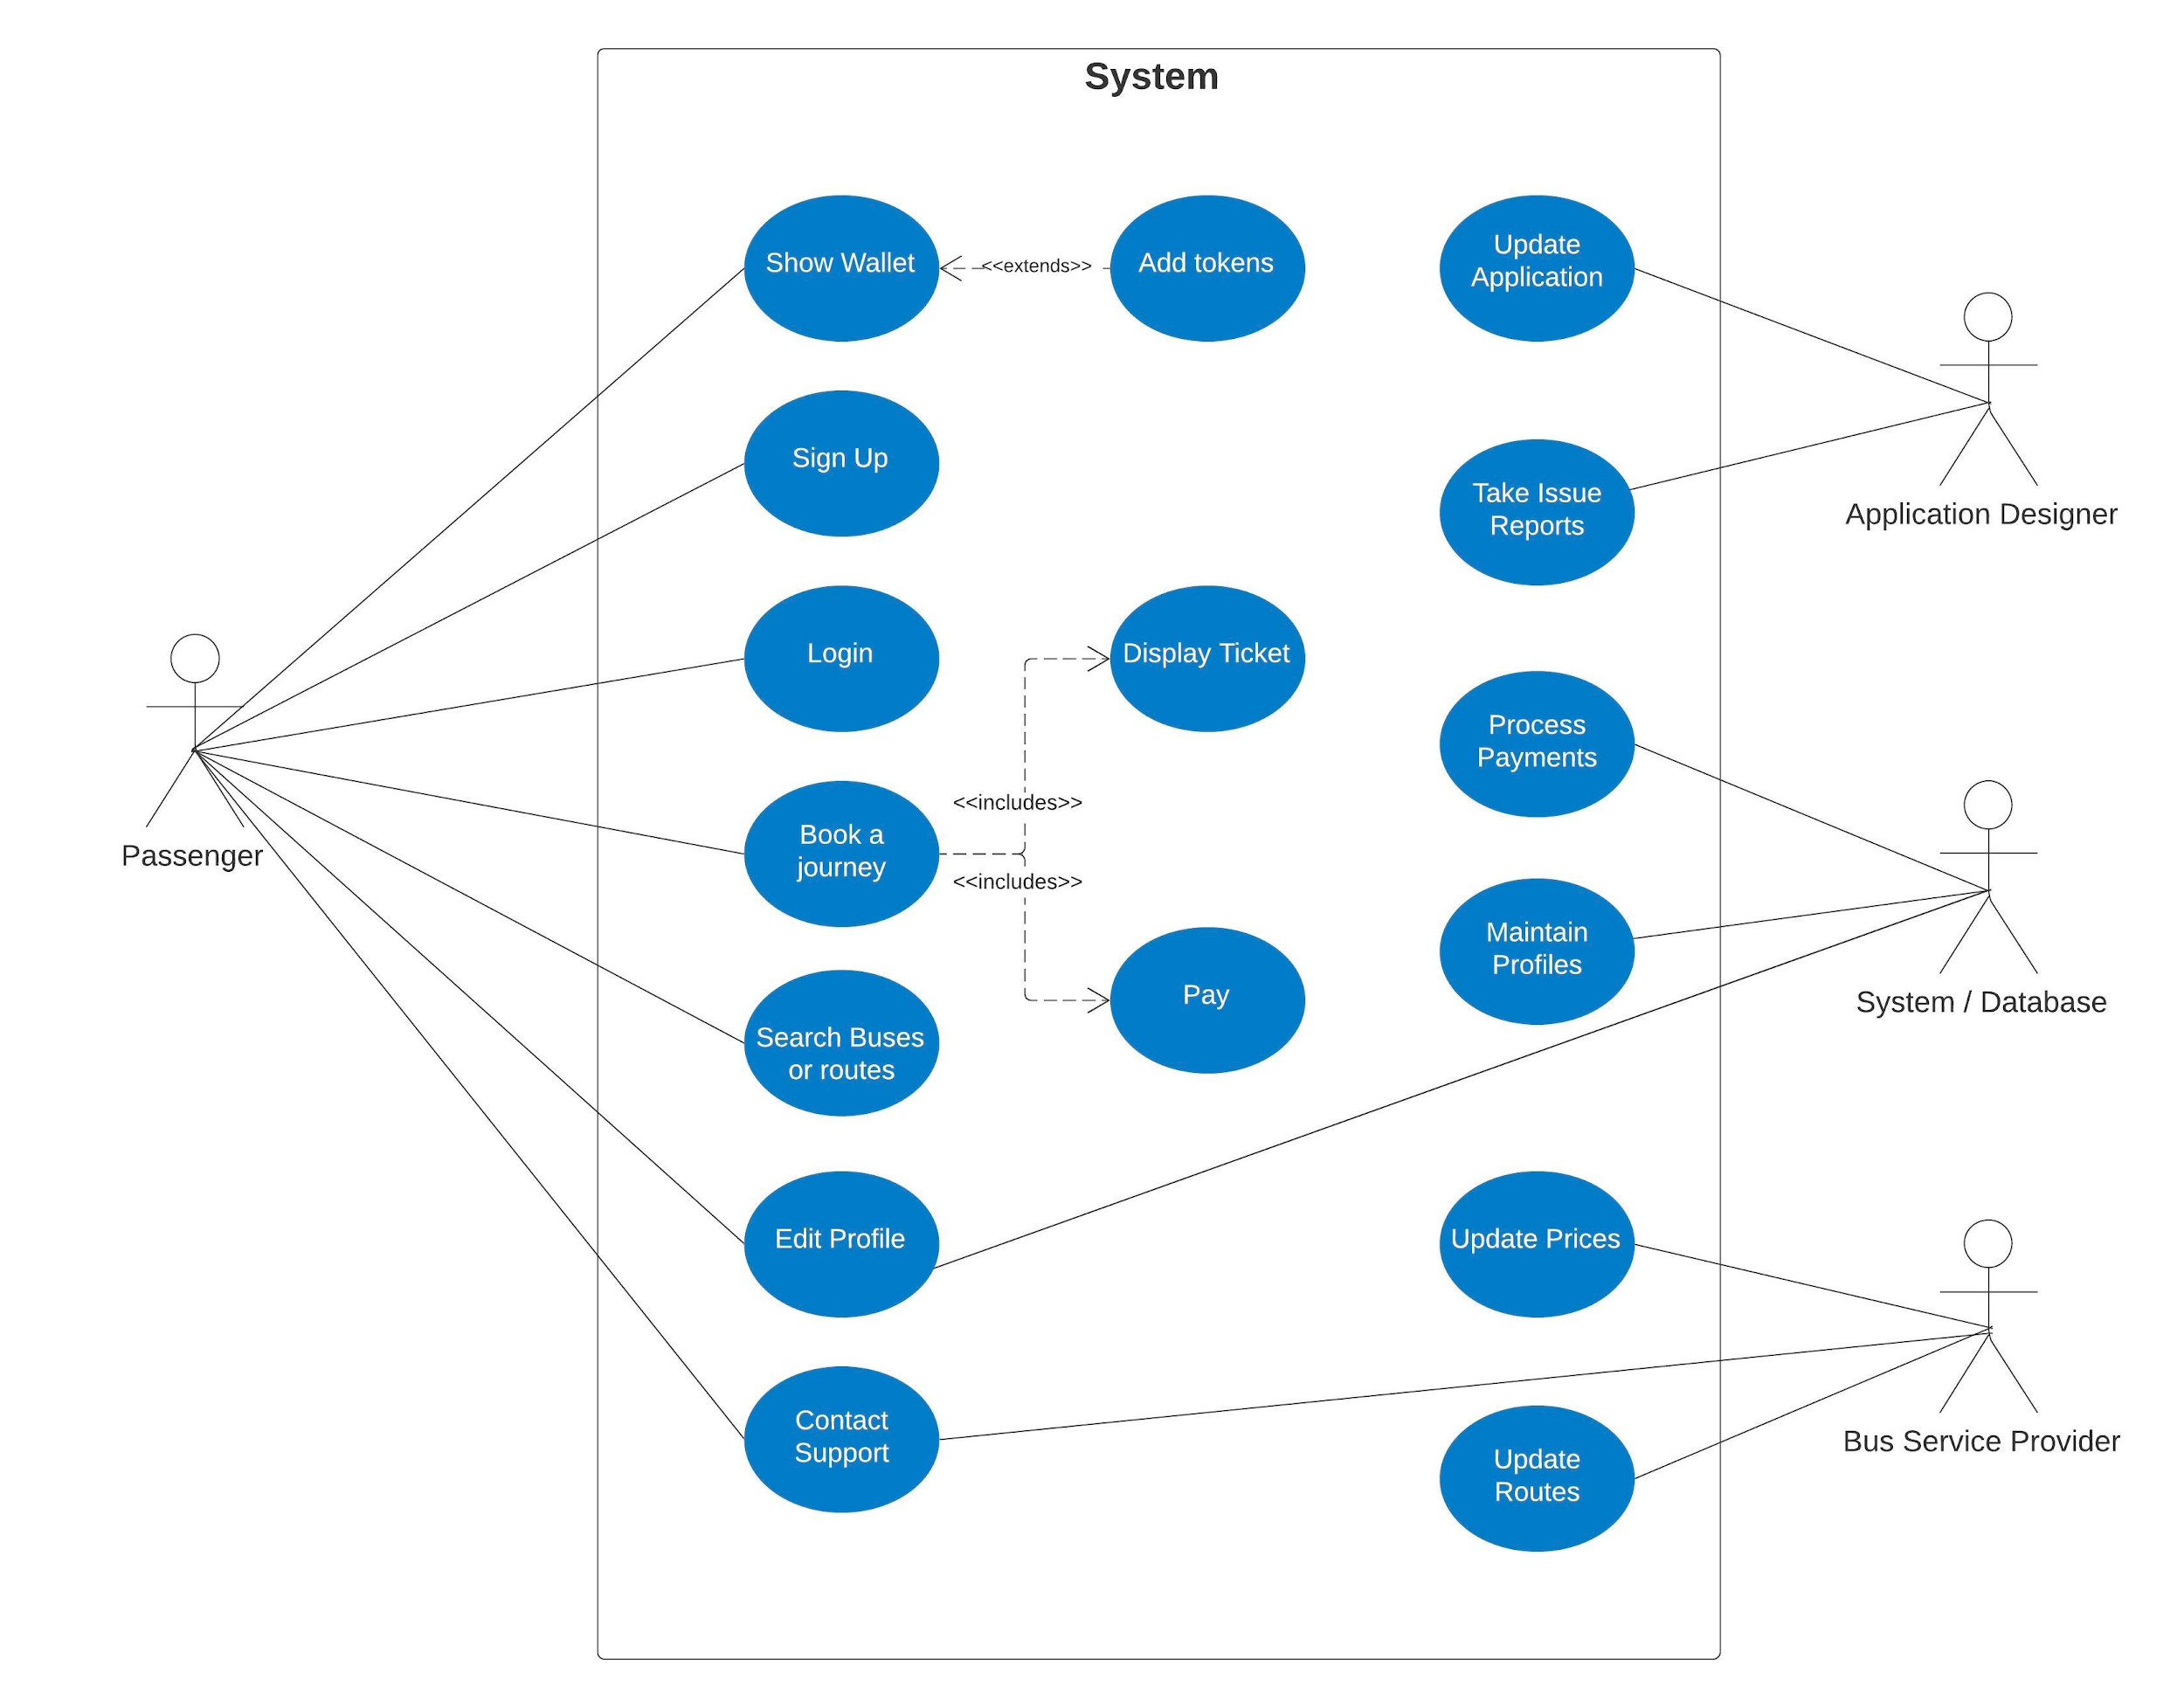

## 

## 

## 

## 

## 

## 

## 

## 

## 

## 

## 

## 

## 

## Conclusion:

We were able to simplify the process of PMPML bus ticket booking.The Bus conductors would be at little ease after using this app as this app would share their work load.

Commuters would also find it more convenient than the traditional process.

## Future Scope:

Real time notifications provided to the user.

These notifications are related to bus delay,changes in routes and timetables,congestions in roads,estimated time to destination.

By providing extra hardware,we can achieve completely automated process.In this process user does not need to do anything.He/She enters the bus,some hardware gets to know the source of the user(where did he/she get in),gets off the bus and a payment is automatically made to the department.

## References:

Google Firebase Firestore documentation:

<https://firebase.google.com/docs/firestore>

StackOverFlow:

[https://stackoverflow.com](https://stackoverflow.com/)

Paytm Integration:

<https://developer.paytm.com/docs/v1/android-sdk/>